Burning Salts!!!

By Benjamin and ­­­­­­­­­_______________

July 20, 2014

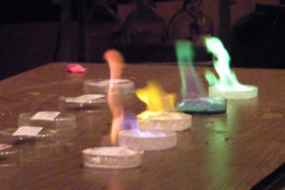

Statement of Purpose and Intention

This experiment was conducted to explore and determine what kind of reaction happens when burning different types of salts and identifying the ions in the salts.

Materials

1. Bunsen Burner
2. Six different types of liquid unknown salts
3. Iron Rod
4. Six petri dish
5. Safety goggles, lab coats

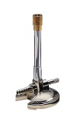



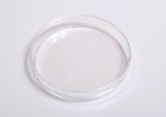





Experimental Matrix

1. Separate all salt samples into six petri dishes.
2. Light the Bunsen burner.
3. Take the iron rod and dip it into a salt sample and insert the tip of the rod in the fire.
4. Carefully observe and take note of the color change.
5. Repeat steps three and four until all salts are sampled.

Data and Observation

|  |  |  |
| --- | --- | --- |
| Sample Salt Number | Color Change | Possible Compound |
| One | Bright Orange | Sodium Chloride |
| Two | Red | Strontium Chloride |
| Three | Pinkish Red | Potassium Nitrate |
| Four | Green | Copper Sulfate |
| Five | Light Purple | Potassium Chloride |
| Six | Red Orange | Calcium Chloride |

Conclusion

When salts are heated, their electrons get excited. When excited these electrons jump energy levels. The number of levels that an electron jumps determines the color of the salt thus resulting in the abnormal color of the flames. While conducting the experiment, it was determined that the mixing of salts resulted in no color change. This could have happened because the electrons jumping counteracted each other resulting in the normal color of fire which was observed as yellow orange with a tint of blue inside.